Cover Letter

The Author details for all authors are compulsory and the mandatory fields are indicated by the asterisk (*).

*Title of the manuscript………………………………………………………………………………………………………………………

*Type of the Article………………………………………………………………………………………………………………………………

*Source of support……………………………………………………………………………………………………………………………….

*Conflicts of interest……………………………………………………………………………………………………………………………

*Corresponding Author (Yes / No)
Salutation (Prof., Dr., Mr., Ms., Mrs., etc.)
*First Name
*Last Name (Family Name)
*Designation (Author Post/ Scholar/Student)
*Affiliation (Department, University, City, Country)
*Email
Website
Address (City, State, Country)
*ORCID
*Google Scholar ID
Scopus ID
*Reviewers Credit ID

For additional authors replicate the table / add the same copy of the table to add details of additional authors.

Date:

Dear Editor,
I am submitting a manuscript for consideration of publication in your esteemed Journal ………………………………………………………………………………..on behalf of all authors. The manuscript is entitled “…………………………………Title of manuscript………………………………………………….”.
It has not been published elsewhere and it has not been submitted simultaneously for publication elsewhere.
A small paragraph on the work explained in the manuscript………………………………………………………………

Thank you very much for your consideration.

Yours Sincerely,
Corresponding Author details
Affiliation
Address
Tel.: +91-0000000000; Fax: +91-0000000000
E-mail: abc@xyz.com

Graphical Abstract (without Author Details)
Example:

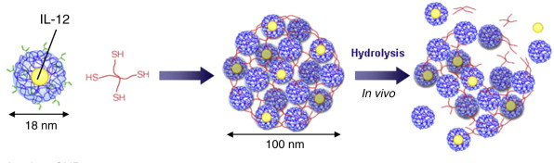

What is Graphical Abstract?
Graphical abstracts are a single image and are designed to help the reader to quickly gain an overview on a scholarly paper, research article, thesis or review: and to quickly ascertain the purpose and results of a given research, as well as the salient details of authors and journal. Graphical abstracts are intended to help facilitate online browsing, as well as help readers quickly identify which papers are relevant to their research interests.

